Technology Stack
Project Design Phase-II — Architecture & Stack
Date | 31 January 2025
Team ID | SWTID-2026-1074
Project Name | SB Stocks
Team Size | 5
Team Leader | Venkatesh Illa
Team Members | Durga Meghana Kondempudi, Chandrika Narla, Mogali Shyam, Sravani Jagu
Maximum Marks | 4 Marks

Table 1: Components & Technologies
S.No | Component | Description | Technology
1 | User Interface | React.js SPA — Home, Portfolio, StockChart, History, Profile, Admin pages | React.js, React Router DOM, Redux, Vite, CSS3, React Toastify
2 | Application Logic-1 | User authentication, registration & wallet logic | Node.js, Express.js (userController.js)
3 | Application Logic-2 | Stock listing & simulated live-price engine (4s interval) | Node.js, Express.js (stockController.js)
4 | Application Logic-3 | Order (Buy/Sell) processing & portfolio holding calculations | Node.js, Express.js (orderController.js)
5 | Database | Users, Stocks/Holdings, Orders, Transactions collections | MongoDB Atlas, Mongoose ODM
6 | Cloud Database | Managed cloud-hosted MongoDB cluster | MongoDB Atlas
7 | File Storage | Static frontend assets (illustrations, build output) | Vercel static hosting
8 | External API | Market data is internally simulated — no paid external market-data API is used | In-memory simulation engine
9 | Infrastructure (Server / Cloud) | Backend deployed on Railway; frontend deployed on Vercel | Railway, Vercel

Table 2: Application Characteristics
S.No | Characteristic | Description | Technology
1 | Open-Source Frameworks | Frameworks used to build client and server | React.js, Express.js, Mongoose
2 | Security Implementations | Authentication & data-protection controls | JWT (jsonwebtoken), bcryptjs password hashing, CORS, role-based adminProtect middleware
3 | Scalable Architecture | Stateless REST API + cloud database supports scaling out | Node.js cluster-ready Express API, MongoDB Atlas horizontal scaling
4 | Availability | Independent hosting for frontend/backend/database improves uptime | Vercel (frontend), Railway (backend), MongoDB Atlas (database)
5 | Performance | Lightweight JSON REST responses and interval-based price updates | Express.js REST API, in-memory market-data cache

SB Stocks — Technology Stack Flow Diagram
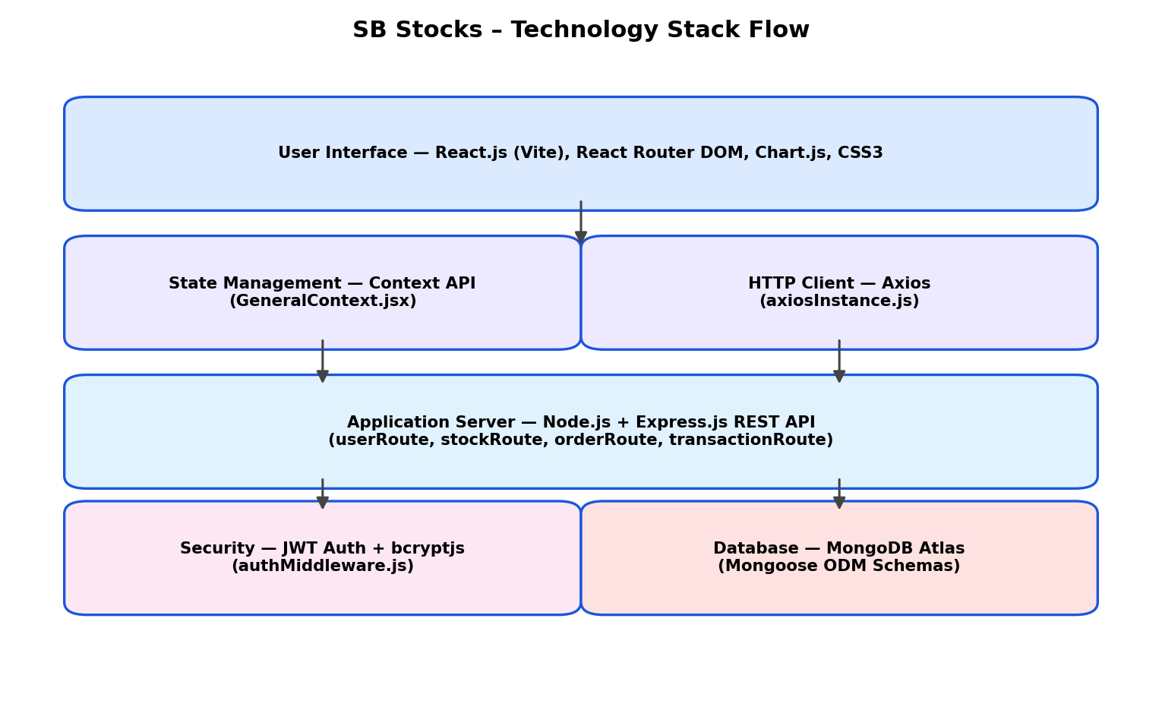
Figure: Layered technology stack used in SB Stocks, from the React UI down to the MongoDB Atlas persistence layer.

